Postman Instructions

This document will describe how to import the test collection and run them in postman.

1. Import the json file into postman. File is in the git repo here /rest-web-service/Postman/REST_web_service_training.json 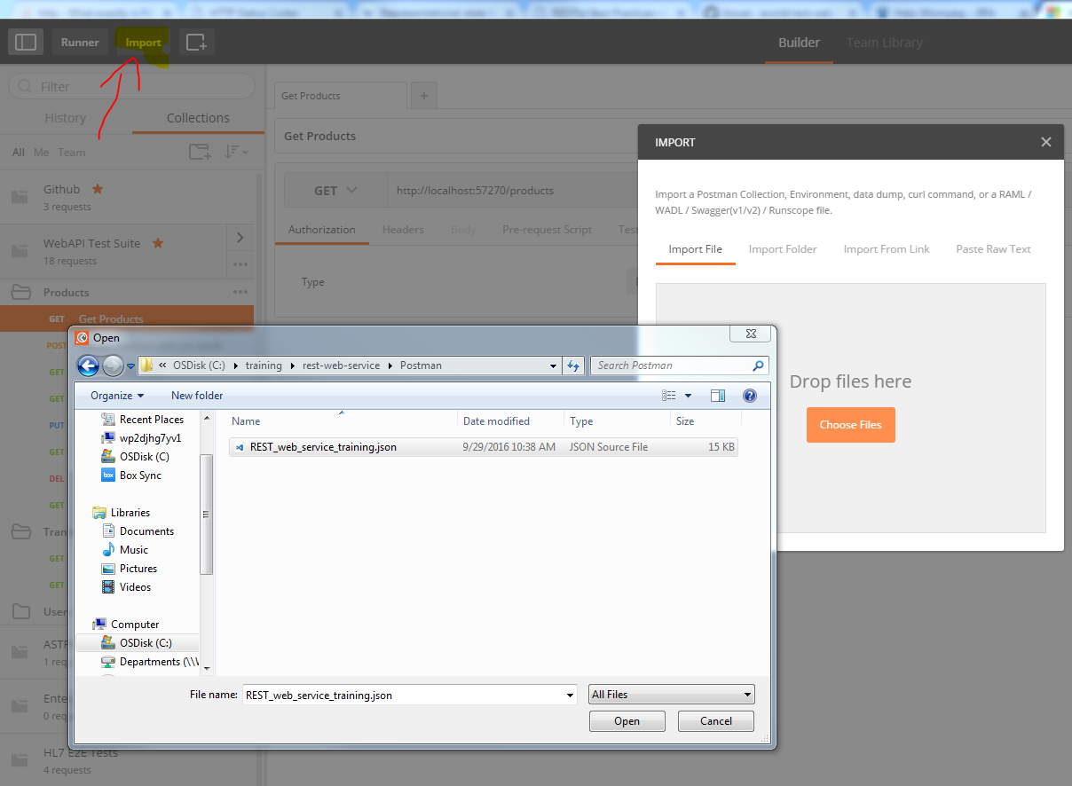
2. Open the “Runner” which is the button beside Import and select “WebAPI Test Suite” for the current run. Click “Start Test” and all tests will run. No need to change the number of iterations or delay.

